**SQL with Postgres Assignment:**

1. Create the HR database using the following scripts.

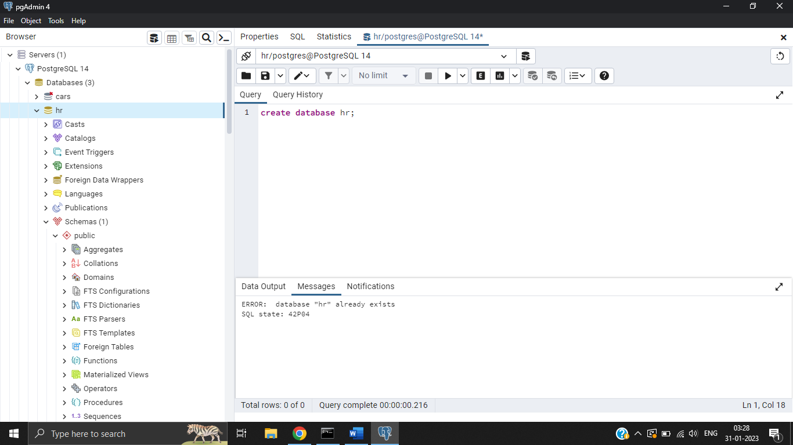

2. Create an ER diagram for the Database schema.

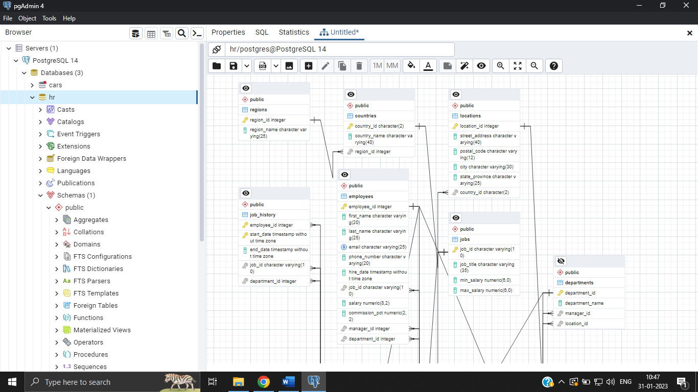

1. write a SQL query to find those employees whose salaries are less than 6000. Return full name (first and last name), and salary.

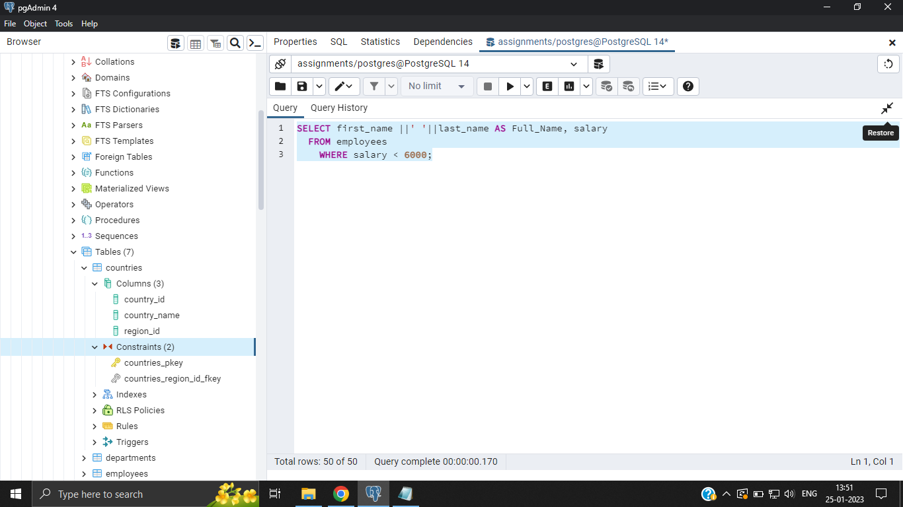

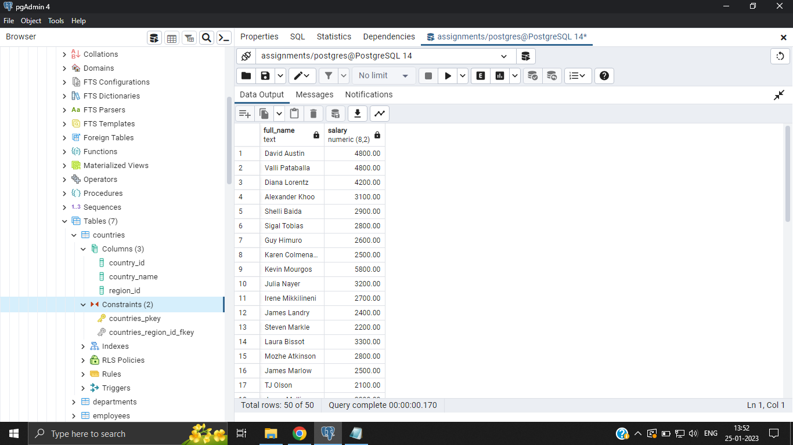

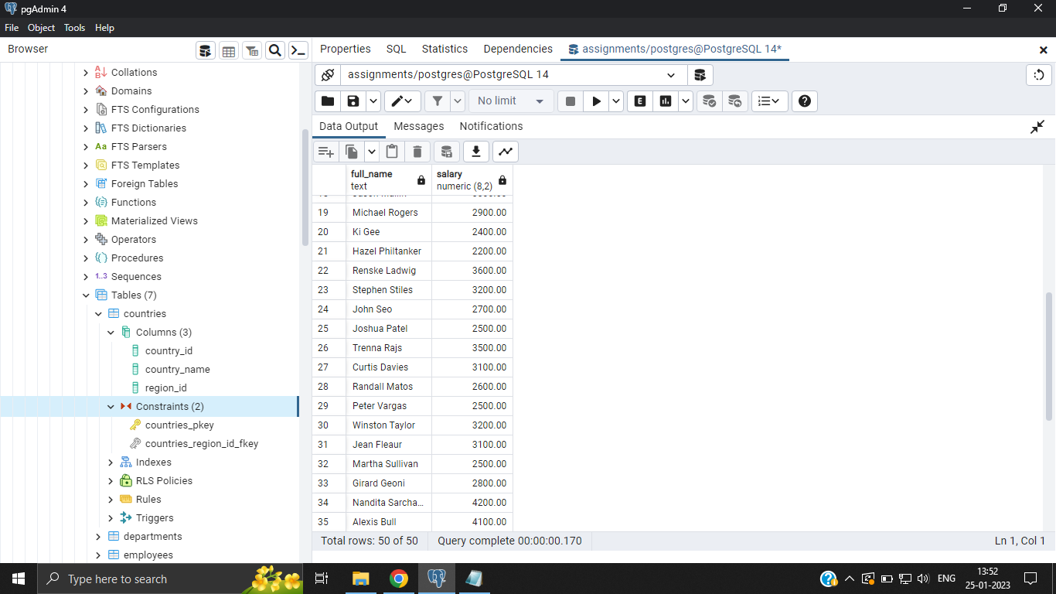

1. write a SQL query to identify employees who do not have a department number. Return employee_id, first_name, last_name, email, phone_number, hire_date, job_id, salary,commission_pct, manager_id and department_id

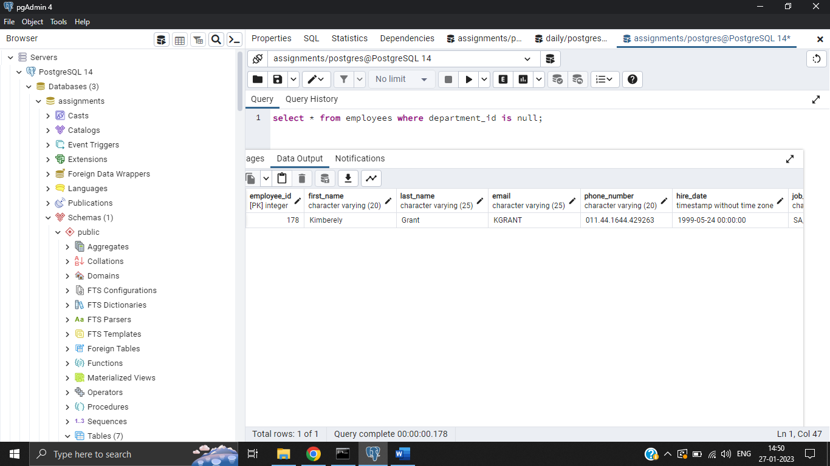

1. write a SQL query to find the details of 'Marketing' department. Return all fields.

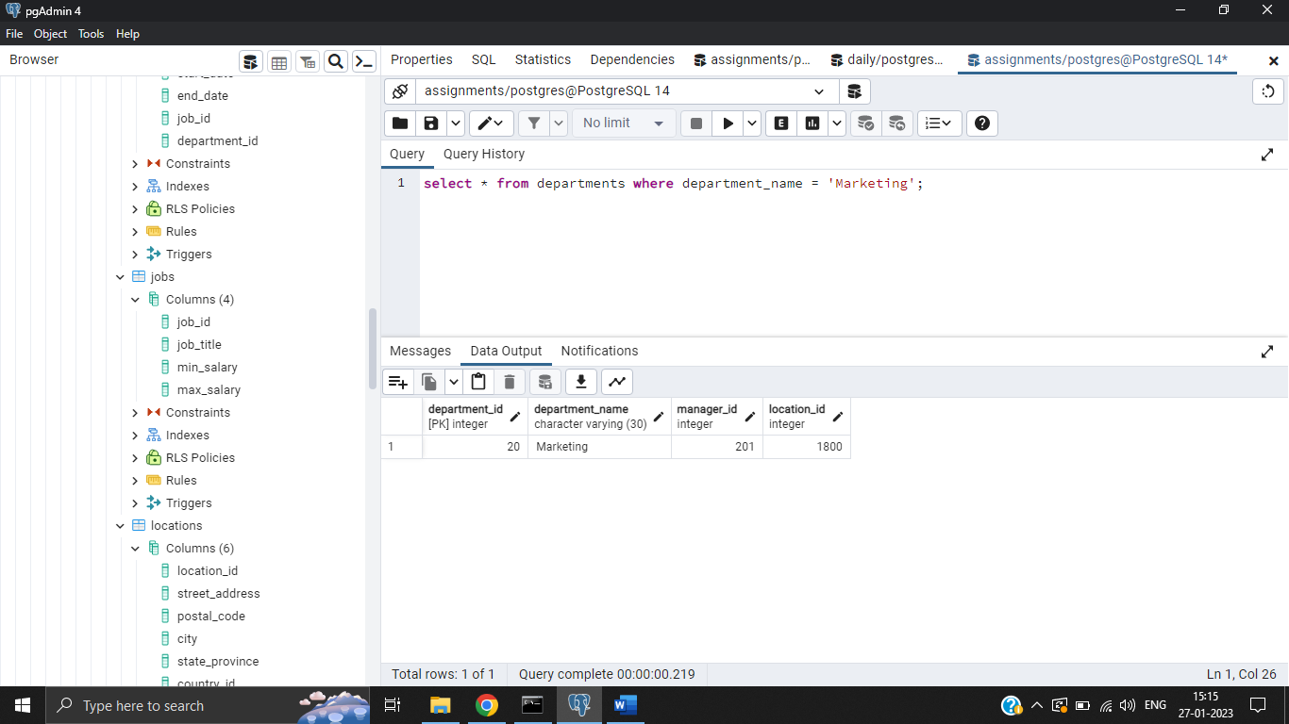

1. write a SQL query to find those employees whose first name does not contain the letter ‘M’. Sort the result-set in ascending order by department ID. Return full name (first and last name together), hire_date, salary and department_id.

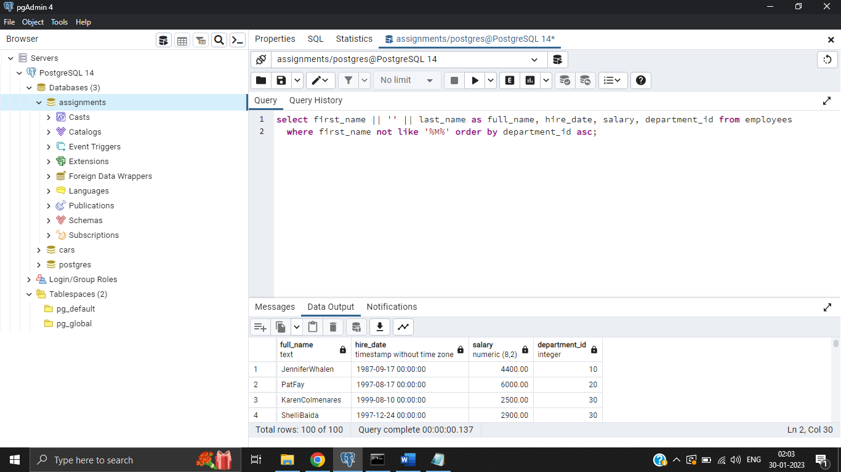

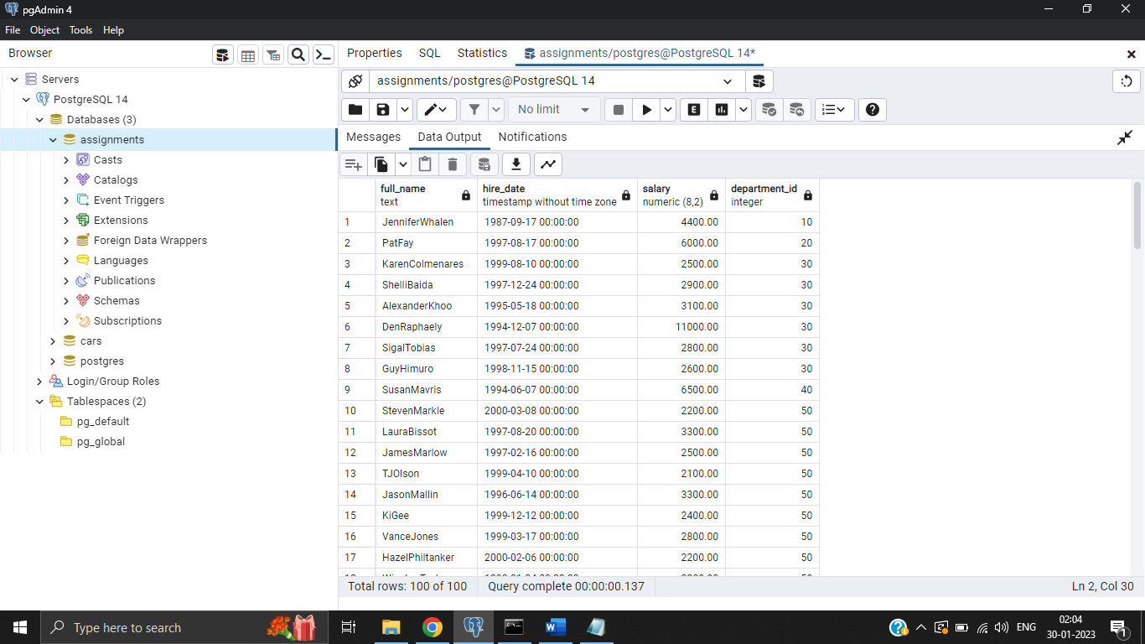

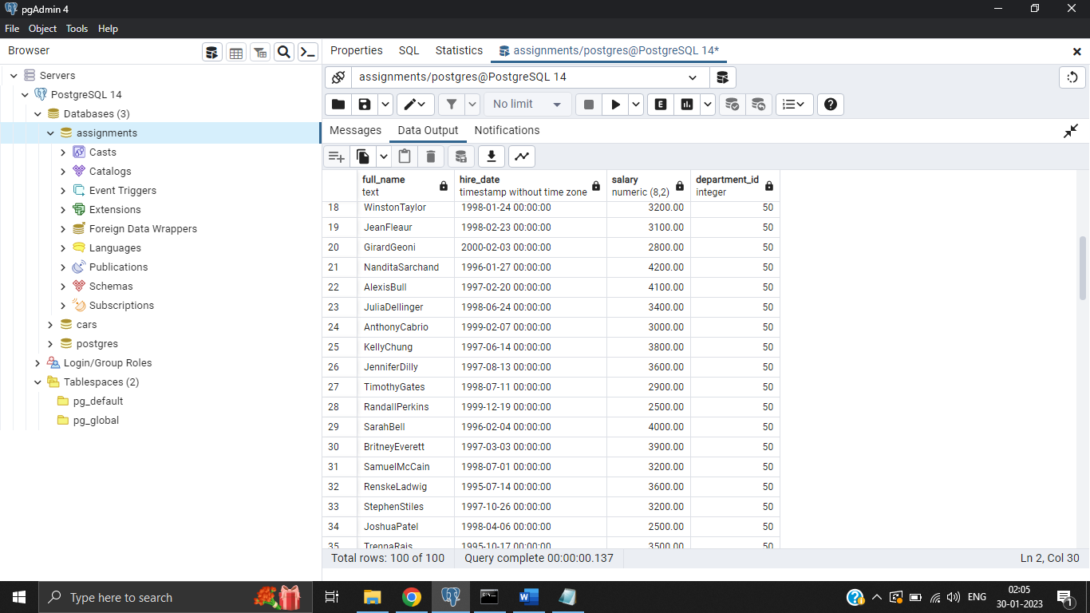

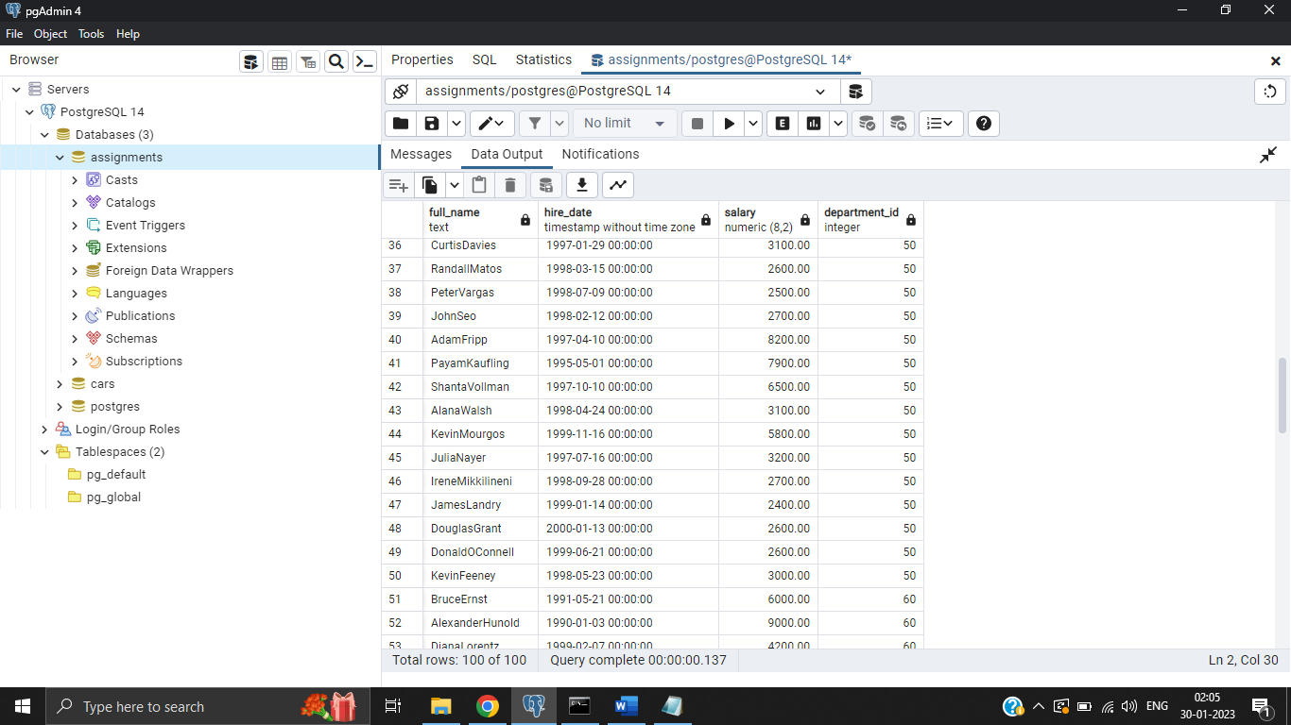

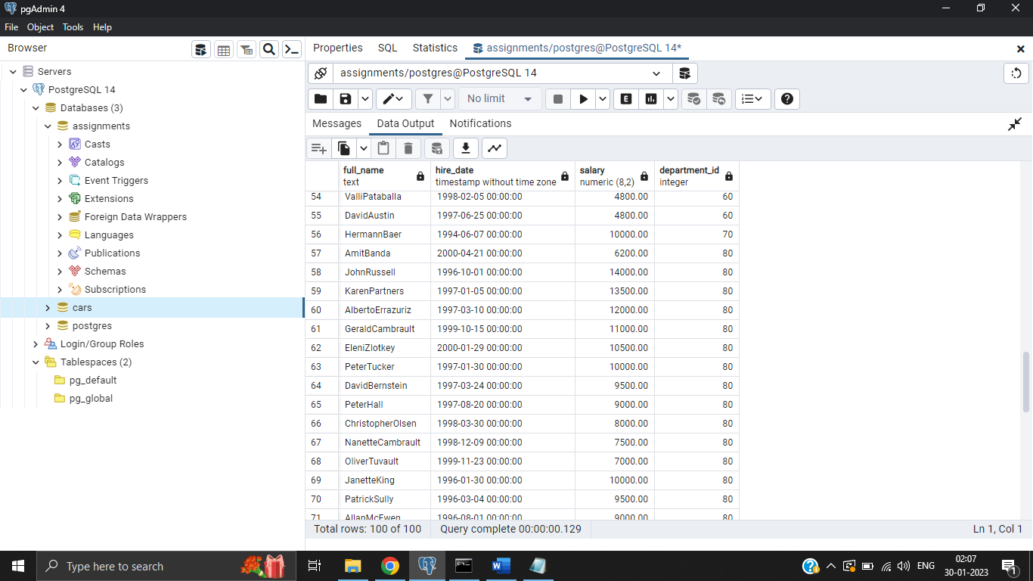

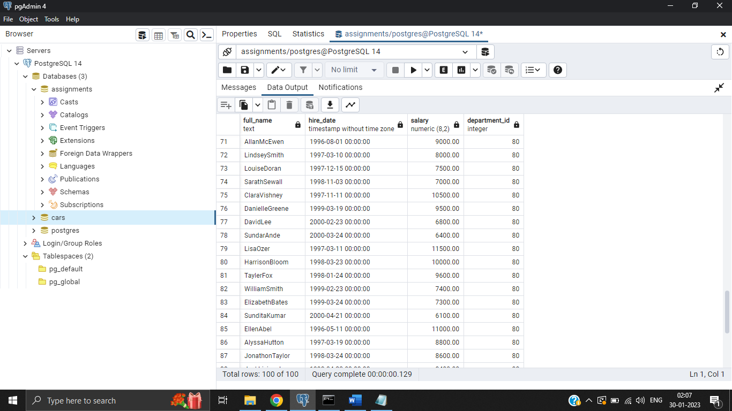

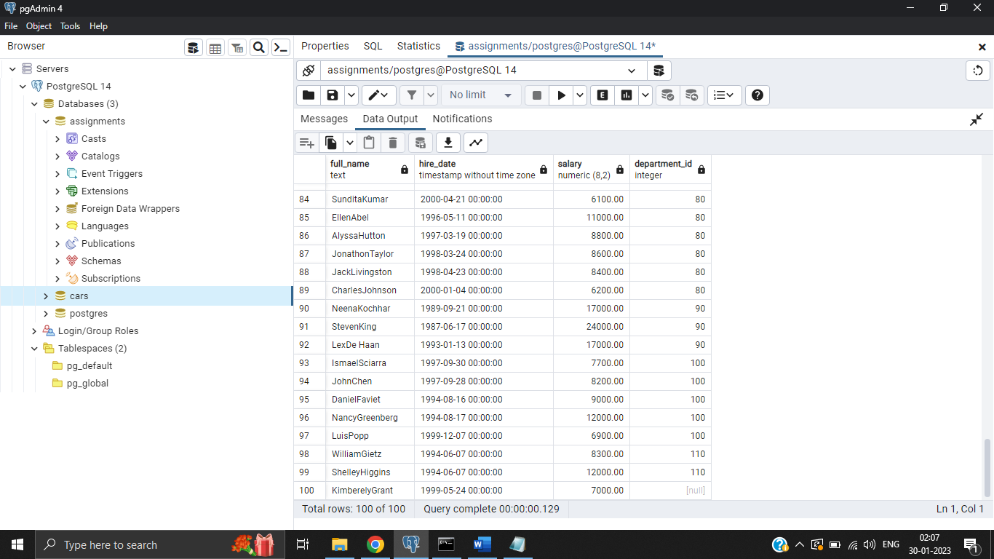

1. write a SQL query to find those employees who were hired between November 5th, 2007 and July 5th, 2009. Return full name (first and last), job id and hire date

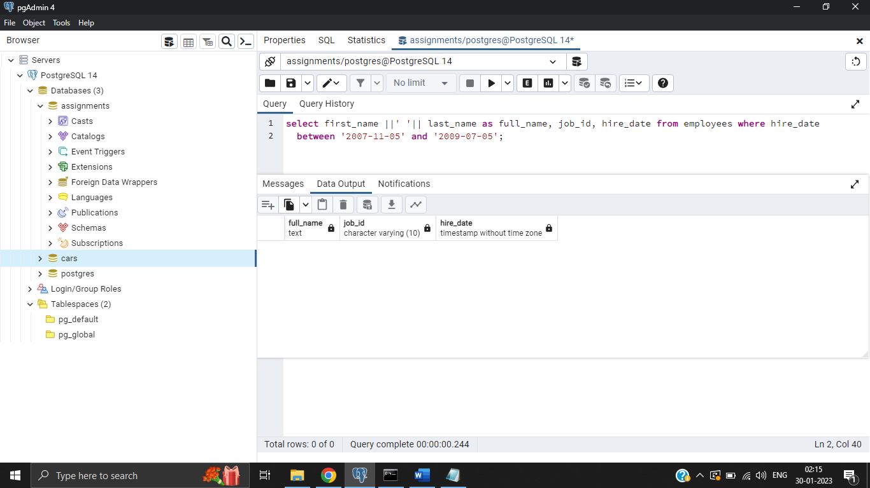

1. write a SQL query to count the number of employees, the sum of all salary, and difference between the highest salary and lowest salaries by each job id. Return job_id, count, sum, salary_difference.

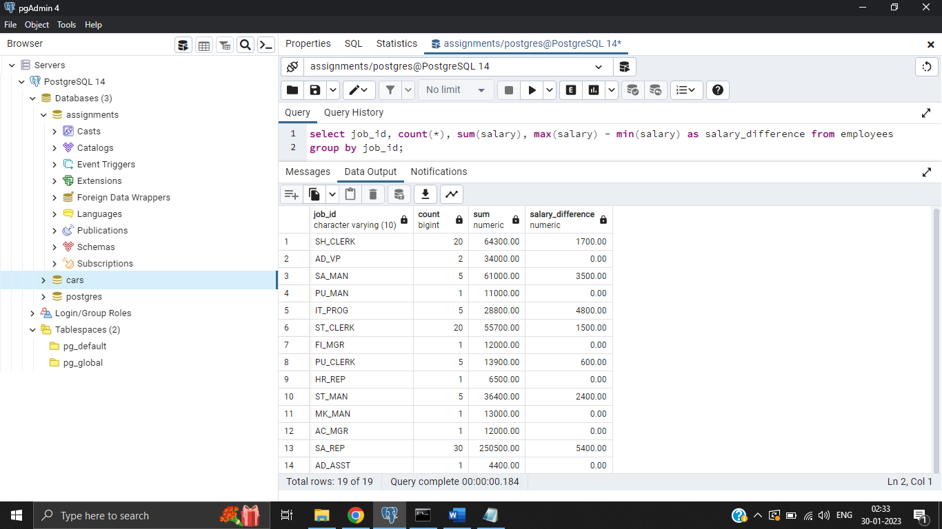

1. write a SQL query to find the departments where more than ten employees receive commissions. Return department id

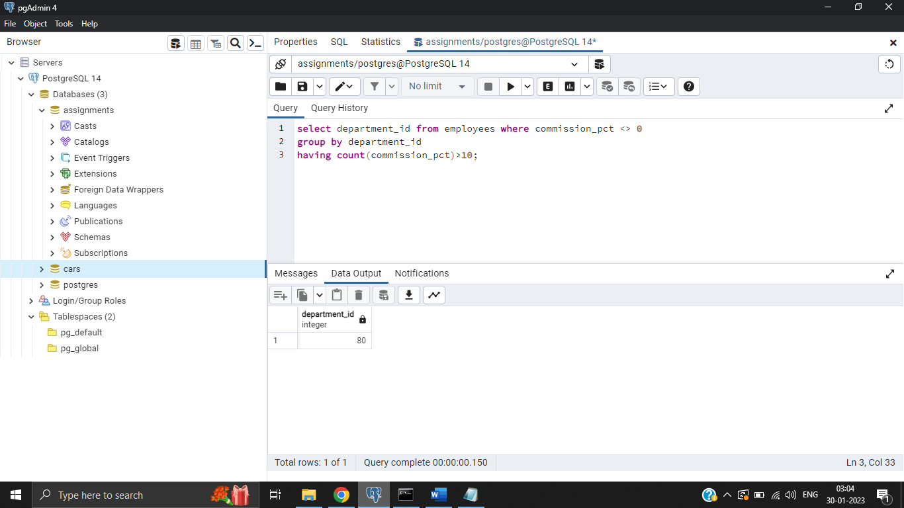

1. write a SQL query to find those employees whose salary matches the lowest salary of any of the departments. Return first name, last name and department ID

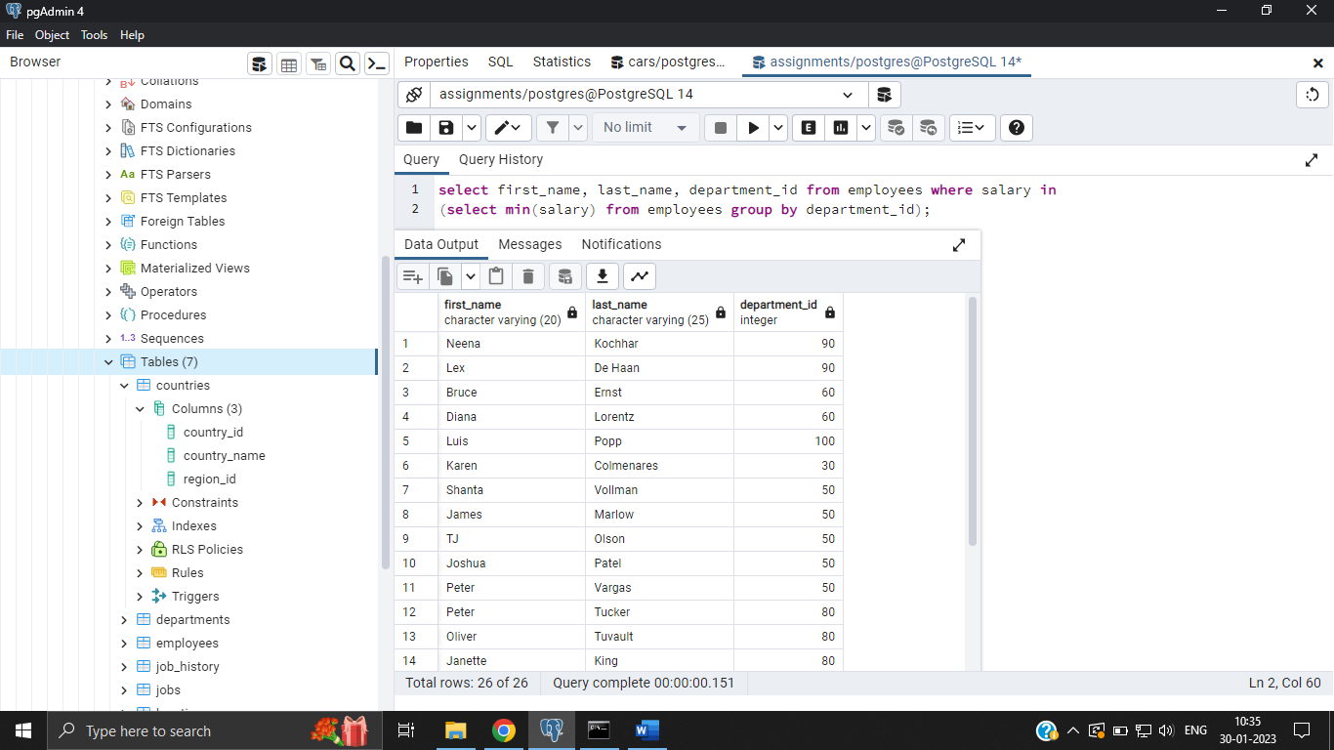

1. write a SQL query to find all those employees who work in the Finance department. Return department ID, name (first), job ID and department name

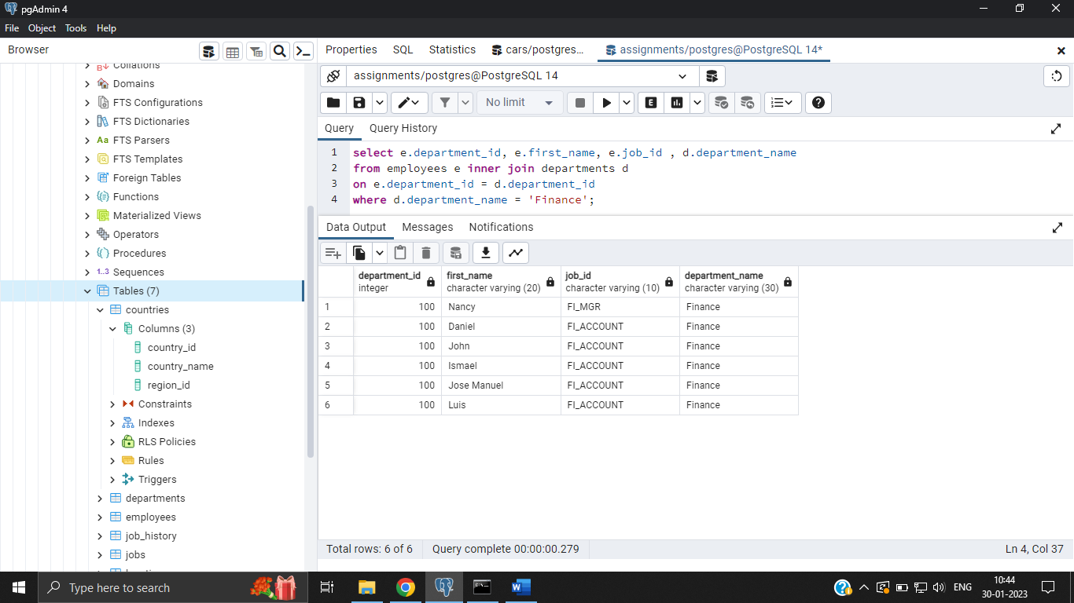

1. write a SQL query to find those employees who get second-highest salary. Return all the fields of the employees

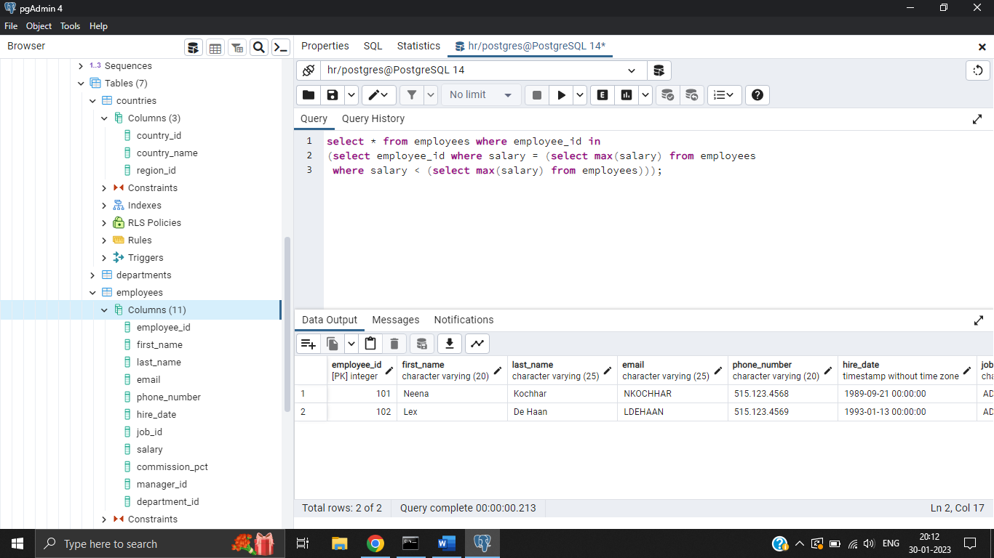

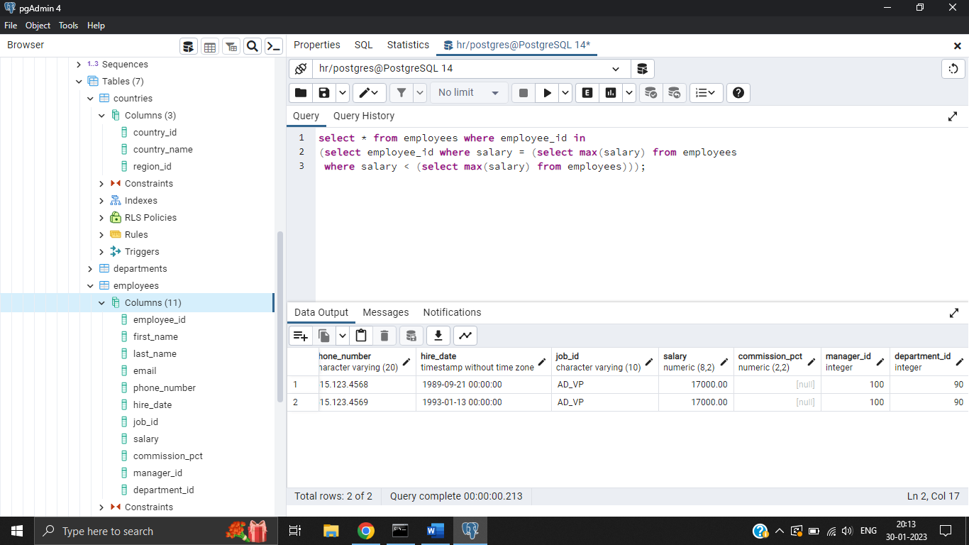

1. write a SQL query to find those employees who earn more than the average salary and work in the same department as an employee whose first name contains the letter 'J'. Return employee ID, first name and salary

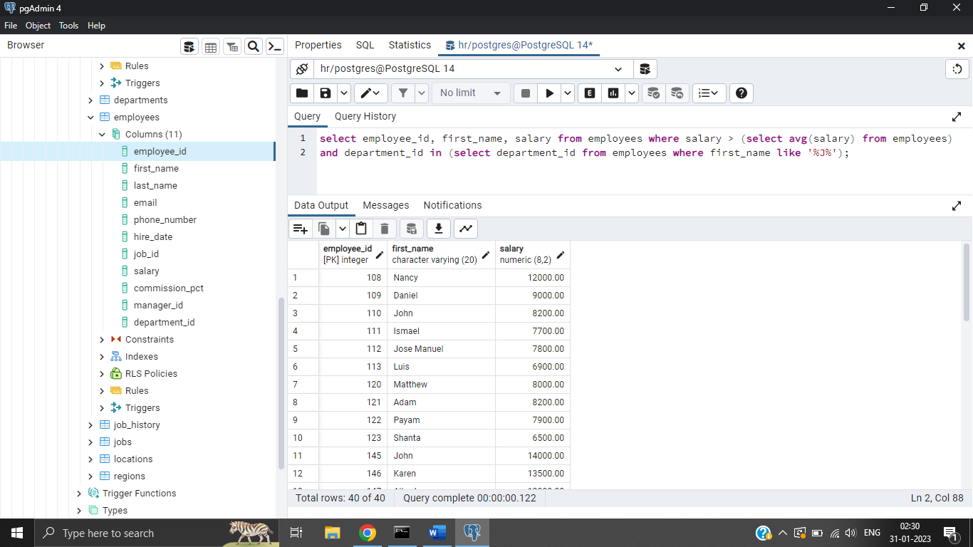

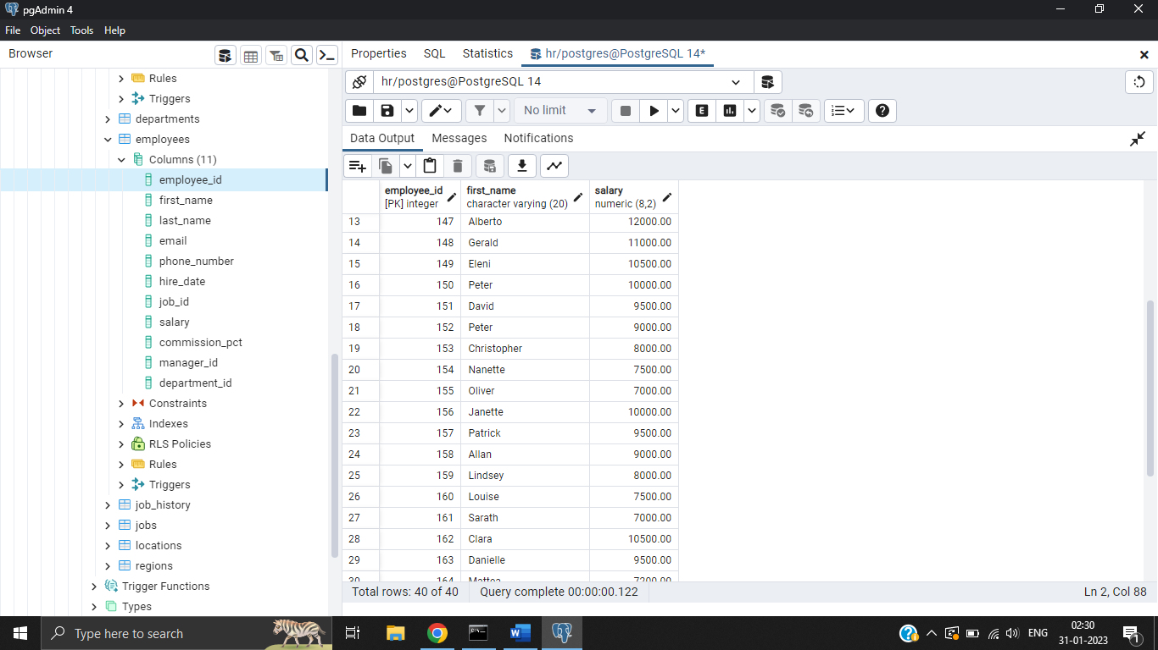

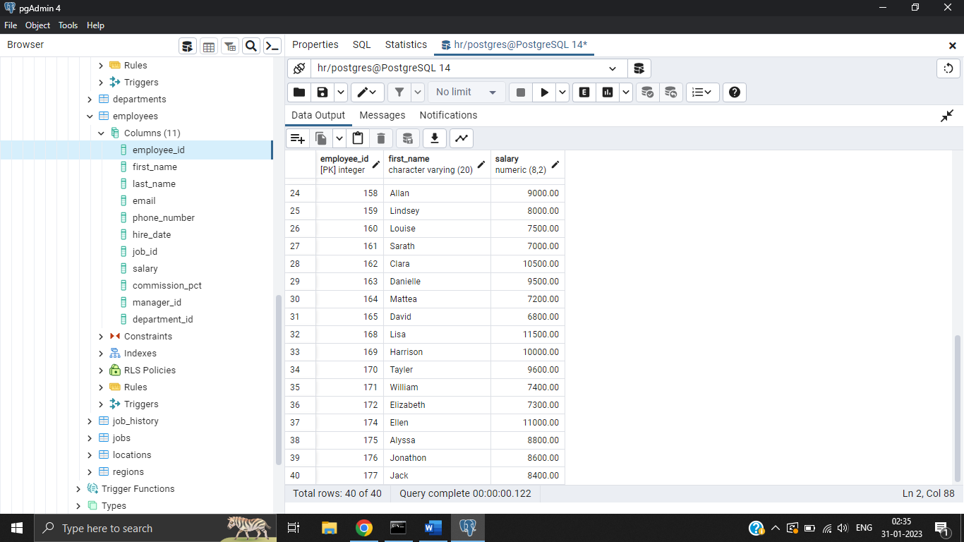

1. write a SQL query to find the first name, last name, department, city, and state province for each employee

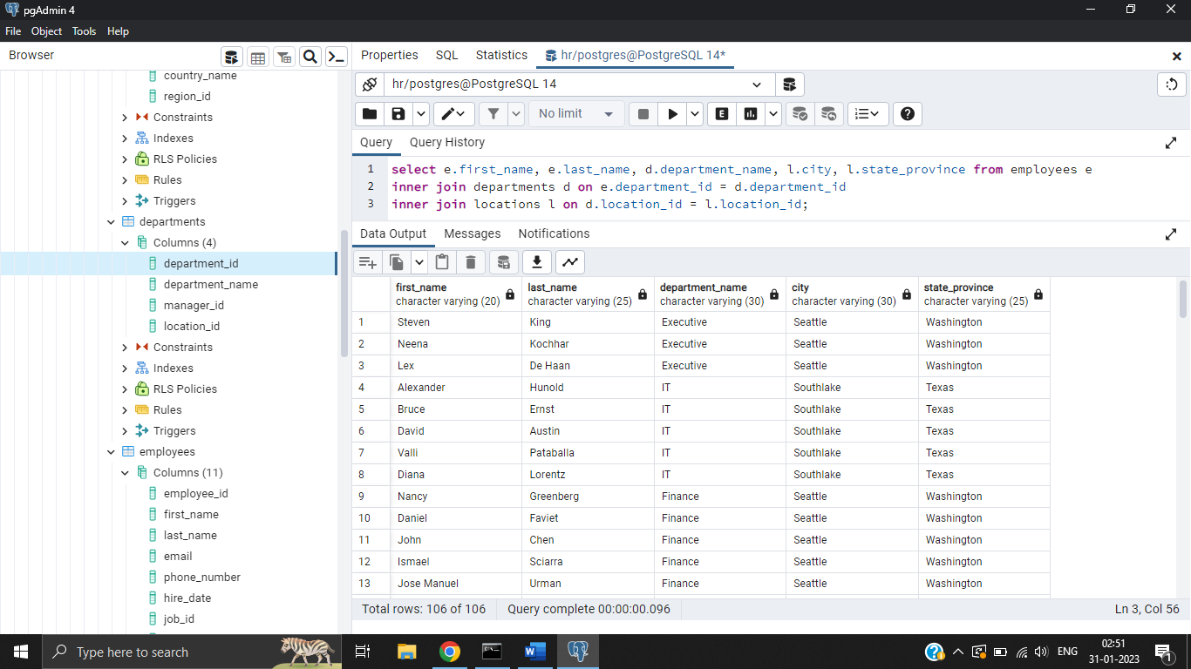

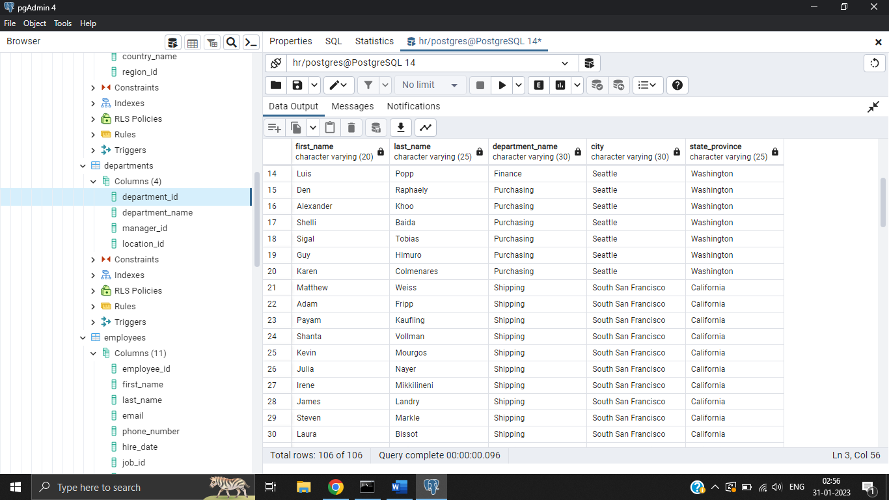

1. write a SQL query to display the department name, city, and state province for each department

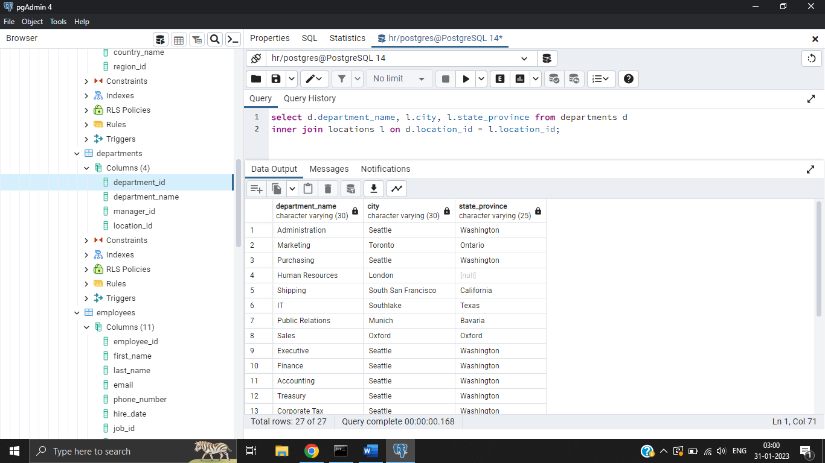

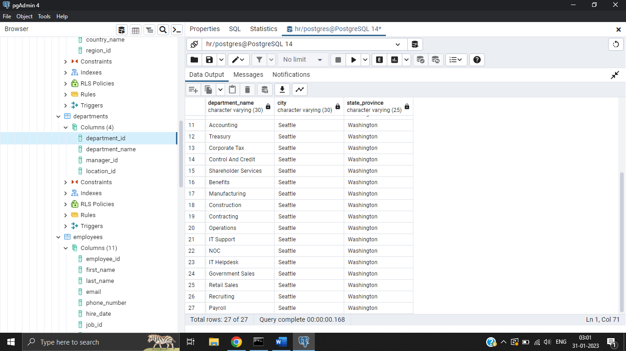

1. write a SQL query to find the department name, full name (first and last name) of the manager and their city

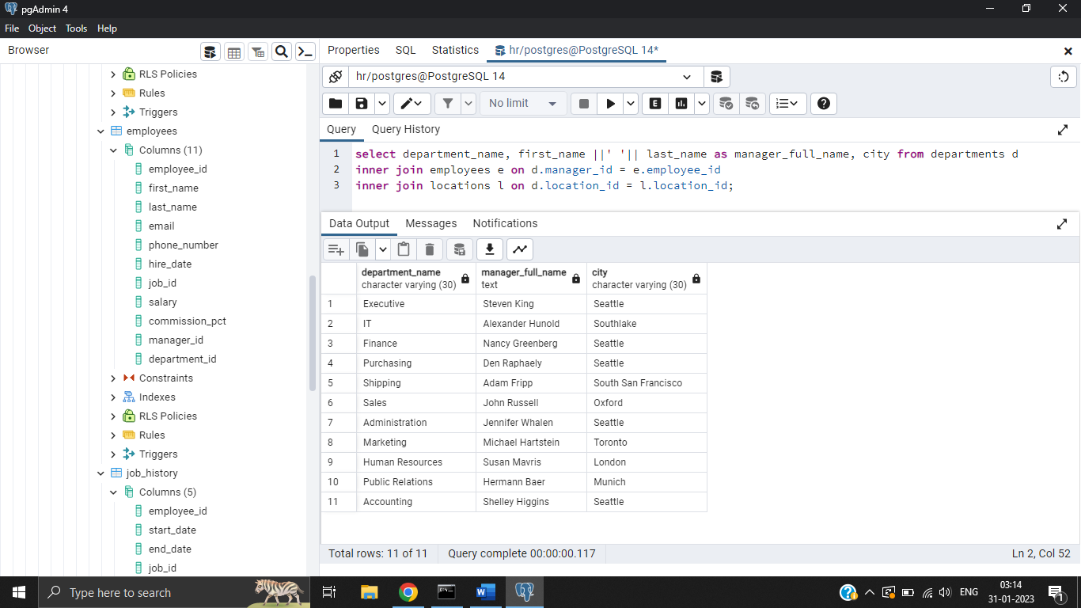

1. write a SQL query to calculate the number of days worked by employees in a department of ID 80. Return employee ID, job title, number of days worked

